Our Voting System
Calhoun County uses a paper-based system of digital precinct scanners for voting and tabulation. We use ES&S DS200 digital scanners at the precincts, and at the Elections Office to process vote-by-mail ballots.
To comply with to federal and state mandates, we have recently added ExpressVote ballot marking devices to our inventory. To meet the mandate for a voting system accessible to those with disabilities, each polling place and early voting site will have at least one ExpressVote in addition to the DS200 digital scanner. The vendor for our voting equipment is Election Systems & Software.
The digital scan method of voting is a user-friendly method that makes voting both fast and simple. Just fill in the oval to the left of the candidate or issue you wish to vote for, as illustrated below:
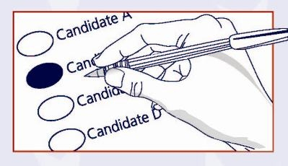
The ExpressVote is simple to use as well. This ballot marking device uses a paper ballot, and allows the option of a touchscreen or audio headset function to mark your ballot. The screen has large-print capability and adjustable screen contrast for better viewing. To use, the voter inserts the ballot into the ExpressVote, then makes selections by touching the screen or by using the audio headset function. You navigate through the ballot and after reviewing all the selections, the ExpressVote will mark the ballot. The ExpressVote will return the ballot after marking it, and the voter then inserts the ballot into the DS200 tabulator.

Information on the DS200 Digital Scanner
- Information on using the DS200

More on the ExpressVote
- ExpressVote Info Sheet
The results from the precincts, early voting, and absentee voting are tabulated together at the Elections Office after the polls close, and are released to the public and posted on our website.

